Course Three

Go Beyond the Numbers: Translate Data into Insights


Instructions
Use this PACE strategy document to record decisions and reflections as you work through this end-of-course project. You can use this document as a guide to consider your responses and reflections at different stages of the data analytical process. Additionally, the PACE strategy documents can be used as a resource when working on future projects.

Course Project Recap
Regardless of which track you have chosen to complete, your goals for this project are:
- Complete the questions in the Course 3 PACE strategy document
- Answer the questions in the Jupyter notebook project file
- Clean your data, perform exploratory data analysis (EDA)
- Create data visualizations
- Create an executive summary to share your results

Relevant Interview Questions
Completing the end-of-course project will help you respond to these types of questions that are often asked during the interview process:
- How would you explain the difference between qualitative and quantitative data sources?
- Describe the difference between structured and unstructured data.
- Why is it important to do exploratory data analysis?
- How would you perform EDA on a given dataset?
- How do you create or alter a visualization based on different audiences?
- How do you avoid bias and ensure accessibility in a data visualization?
- How does data visualization inform your EDA?
Reference Guide
This project has six tasks; the visual below identifies how the stages of PACE are incorporated across those tasks.
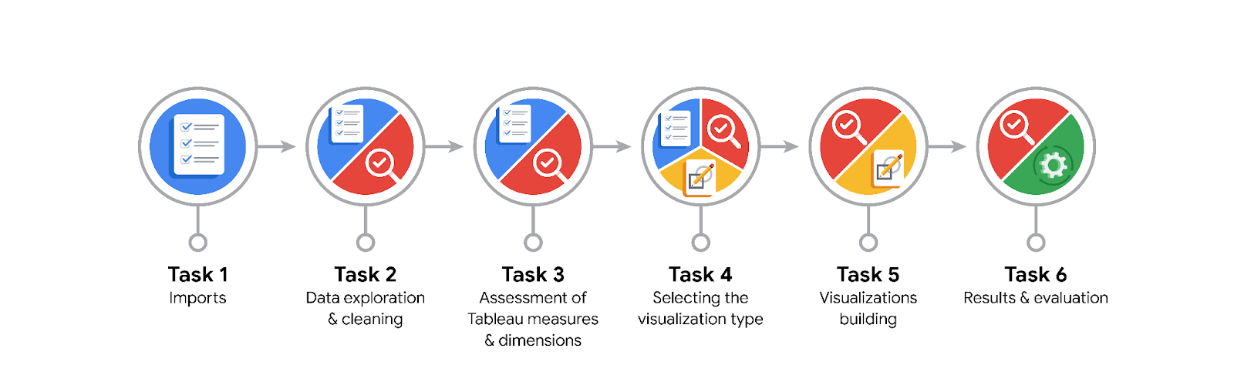
Data Project Questions & Considerations

PACE: Plan Stage
- What are the data columns and variables and which ones are most relevant to your deliverable?
claim_status, video_duration_sec, video_view_count, video_like_count, video_share_count, video_download_count, video_comment_count, author_ban_status, verified_status.
Most relevant: claim_status, engagement metrics, and author status.

- What units are your variables in?
Seconds (duration) and counts (views, likes, shares, downloads, comments).

- What are your initial presumptions about the data that can inform your EDA, knowing you will need to confirm or deny with your future findings?
Claim videos may have higher engagement (views, likes) than opinion videos.

- Is there any missing or incomplete data?
Yes, some missing values in claim_status and engagement columns.

- Are all pieces of this dataset in the same format?
Mostly yes, numeric for counts, categorical for statuses.

- Which EDA practices will be required to begin this project?
Use .head(), .info(), .describe(), boxplots, histograms, scatterplots, and correlation checks.

PACE: Analyze Stage
- What steps need to be taken to perform EDA in the most effective way to achieve the project goal?
Inspect data, clean missing values, detect outliers, and visualize distributions.

- Do you need to add more data using the EDA practice of joining? What type of structuring needs to be done to this dataset, such as filtering, sorting, etc.?
No joins needed; only filtering, sorting, and grouping by claim_status.

- What initial assumptions do you have about the types of visualizations that might best be suited for the intended audience?
Bar charts for comparisons, boxplots for outliers, histograms for distributions, scatterplots for relationships.

PACE: Construct Stage
- What data visualizations, machine learning algorithms, or other data outputs will need to be built in order to complete the project goals?
Boxplots, histograms, scatterplots, and bar charts in Python and Tableau dashboards

- What processes need to be performed in order to build the necessary data visualizations?
Clean data, calculate medians/IQR, group by claim_status, and use matplotlib, seaborn, and Tableau.

- Which variables are most applicable for the visualizations in this data project?
video_view_count, video_like_count, video_share_count, video_download_count, video_comment_count, and claim_status.

- Going back to the Plan stage, how do you plan to deal with the missing data (if any)?
Drop or impute missing values as appropriate; small percentage ignored.

PACE: Execute Stage
- What key insights emerged from your EDA and visualizations(s)?
Claim videos get much higher engagement (views, likes) than opinion videos; views and likes are strongly correlated.

- What business and/or organizational recommendations do you propose based on the visualization(s) built?
Prioritize claim-type content to increase engagement and visibility.

- Given what you know about the data and the visualizations you were using, what other questions could you research for the team?
How do verification and ban status influence engagement? What drives virality?

- How might you share these visualizations with different audiences?
Through Tableau dashboards, Python notebooks, and executive summaries with accessible design and clear visuals.

